**Requirement Gathering and Analysis Phase**

**Technology Stack (Architecture & Stack)**

|  |  |
| --- | --- |
| Date |  |
| Team ID | SWTID1720075176 |
| Project Name | Online Complaint Register and Management System |
| Maximum Marks |  |

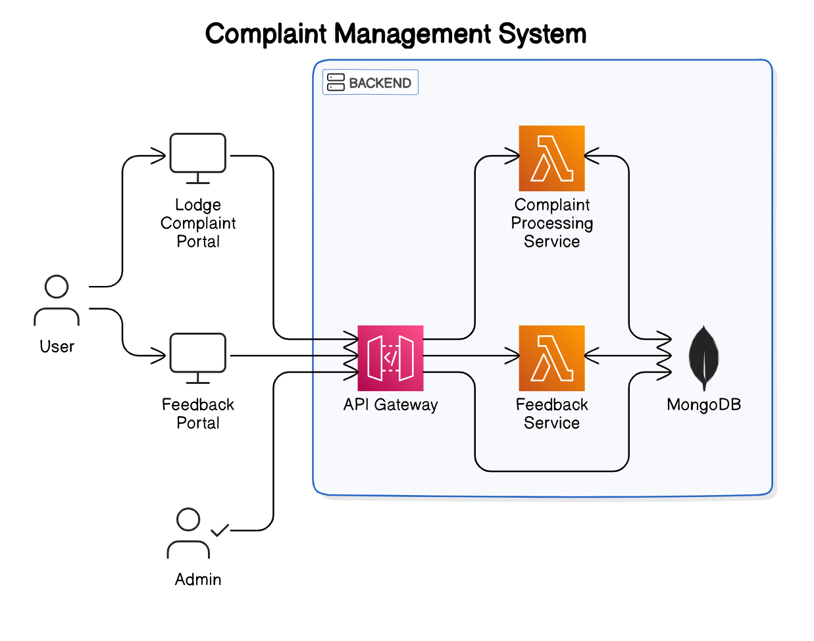

**Table-1 : Components & Technologies:**

|  |  |  |  |
| --- | --- | --- | --- |
| **S.No** | **Component** | **Description** | **Technology** |
|  | User Interface | How user interacts with application | |  | | --- | | HTML, CSS, JavaScript, React.js,  Tailwind CSS, Figma, Bootstrap |  |  | | --- | |  | |
|  | |  | | --- | | **Backend Framework** |  |  | | --- | |  | | |  | | --- | | Server-side application framework |  |  | | --- | |  | | |  | | --- | | Node.js, Express.js |  |  | | --- | |  | |
|  | |  | | --- | | Authentication |  |  | | --- | |  | | User authentication and security | bcrypt |
|  | Application Logic-3 | Logic for a process in the application | IBM Watson Assistant |
|  | Database | Data Type, Configurations etc. | MongoDB |
|  | Cloud Database | Database Service on Cloud | MongoDB Atlas |
|  | File Storage | File storage requirements | Multer, Local Filesystem |
|  | Version Control | Version control system | Git |
|  | UI Design | Tools used for designing the UI | Figma |
|  | **Styling** | CSS frameworks and preprocessors | Tailwind CSS, Bootstrap |
|  | **Testing** | Tools and frameworks used for testing | Thunder Client |

**Table-2: Application Characteristics:**

| **S.No** | **Characteristics** | **Description** | **Technology** |
| --- | --- | --- | --- |
|  | Open-Source Frameworks | None | None |
|  | Security Implementations | Password Encryption | Bycrpt |
|  | Scalable Architecture | 3-Tier Architecture | React |
|  | Availability | Can be used by multiple users at the same time and handle traffice | MongoDB |
|  | Performance | Multiple Users at a Moment | None |